Andrew Rakeman, PhD, Lustgarten Foundation Vice President of Research, and Elizabeth Jaffee, MD, Lustgarten Foundation Chief Medical Advisor and Deputy Director, The Sidney Kimmel Comprehensive Cancer Center at Johns Hopkins, Attend The Alma Mater Studiorum/Lustgarten Foundation Lecture in Bologna, Italy

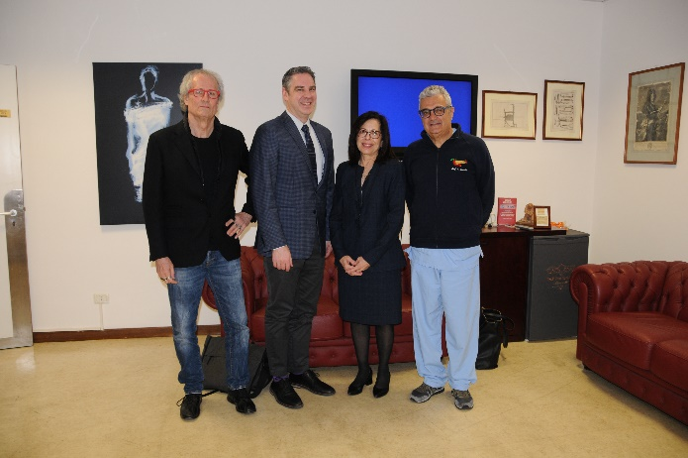
Bologna, Italy – On April 3, 2023, Andrew Rakeman, PhD, and Elizabeth Jaffee, MD, attended the first ever Alma Mater Studiorum/Lustgarten Foundation Lecture in Bologna, Italy at the University of Bologna, led by Professor Riccardo Casadei, MD, Chief of the Pancreatic and Endocrine Surgical Division. The lecture entitled “Pancreatic Cancer: The Commitment of Breakthrough Science for a Better Prognosis” represents an international dedication to advancing pancreatic cancer research.

Pancreatic cancer is the third-leading cause of cancer deaths in the U.S. and has a 5-year survival rate of just 12%. By 2030, the number of new pancreatic cancer cases per year is expected to rise, presenting an emergent threat.

“It was a pleasure to meet with Professor Casadei and the clinical and research teams. The work they are doing is impressive and their dedication to expand clinical pancreatic cancer research is evident,” said Dr. Rakeman. “Bringing together pancreatic cancer scientists transnationally is a step toward realizing the Lustgarten Foundation’s goal to inspire a global community to collaborate and give visibility to this devastating disease.”

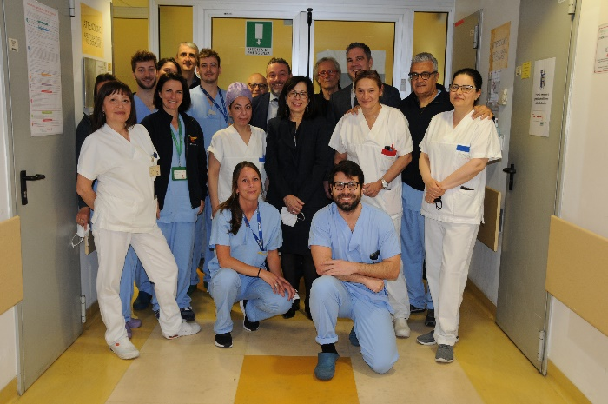
The lecture notably featured remarks by Elizabeth Jaffee, MD, on immunotherapy for pancreatic cancer and how research is providing the road-map for cutting-edge improvements in therapies and hope for better outcomes in the future.

“The Alma Mater Studiorum/Lustgarten Foundation Lecture in Bologna is a hopeful step toward international collaboration in pancreatic cancer research,” said Dr. Jaffee. “It was an honor to meet Professor Casadei and his team and to speak to all in attendance.”

Elizabeth Jaffee, MD, opening lecture remarks:

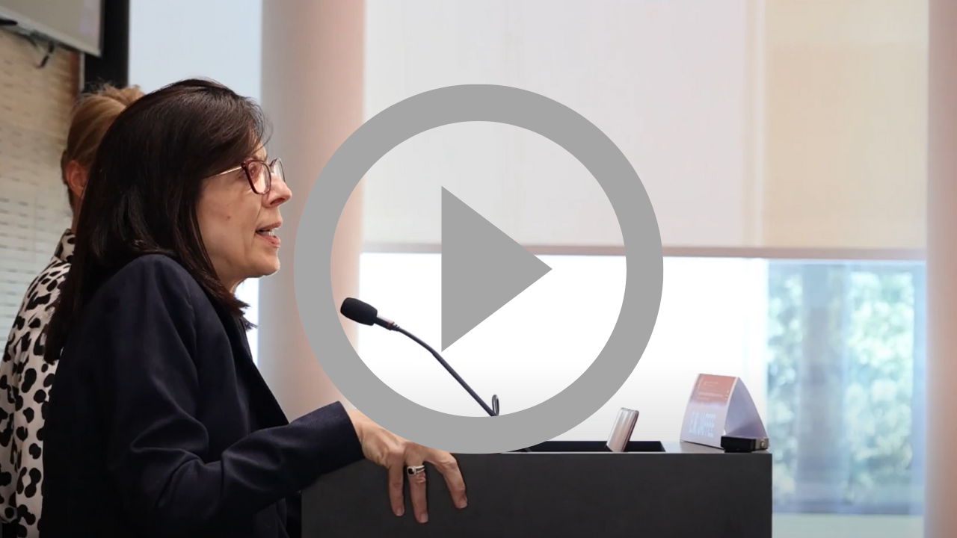

###

About Lustgarten Foundation
The Lustgarten Foundation funds the world’s preeminent pancreatic cancer researchers, driving the pursuit of bold and innovative science toward earlier detection, better treatments and transforming pancreatic cancer into a curable disease. Our mission is rooted in the belief that research is fundamental, in fact, it is the only way to produce real results. Lustgarten-funded science has been a driving force in every major advancement in pancreatic cancer research since 1998, where funding creative risks yield high rewards accelerating and expanding life-saving treatment options. 100% of all donations fuel the research to advance understanding of this complex, devastating and historically underfunded cancer. For more information, visit www.lustgarten.org.

About Sidney Kimmel Comprehensive Cancer Center at Johns Hopkins
2023 marks the 50th Anniversary of the Cancer Center at Johns Hopkins. Learn more about the groundbreaking advancements made throughout the last five decades at hopkinscancer.org.

